Home Works:

Using function:

X(n) = ∏(n+5) = u(n+5)-u(n)

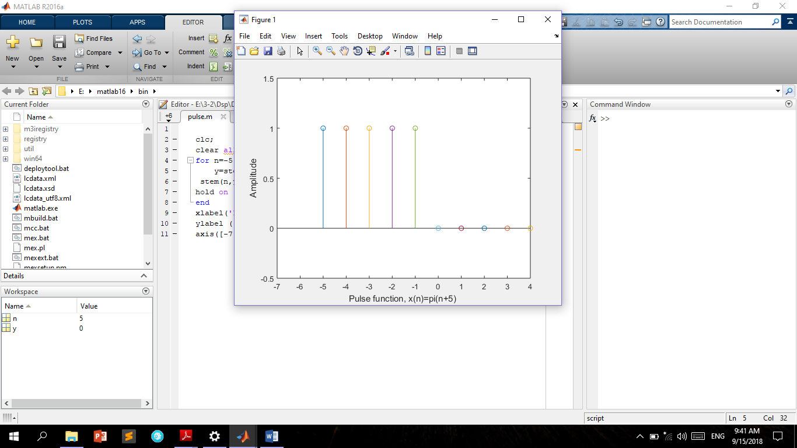

Figure 1.12: pulse signal, x(n)= ∏(n+5)

Home Works:

Using function:

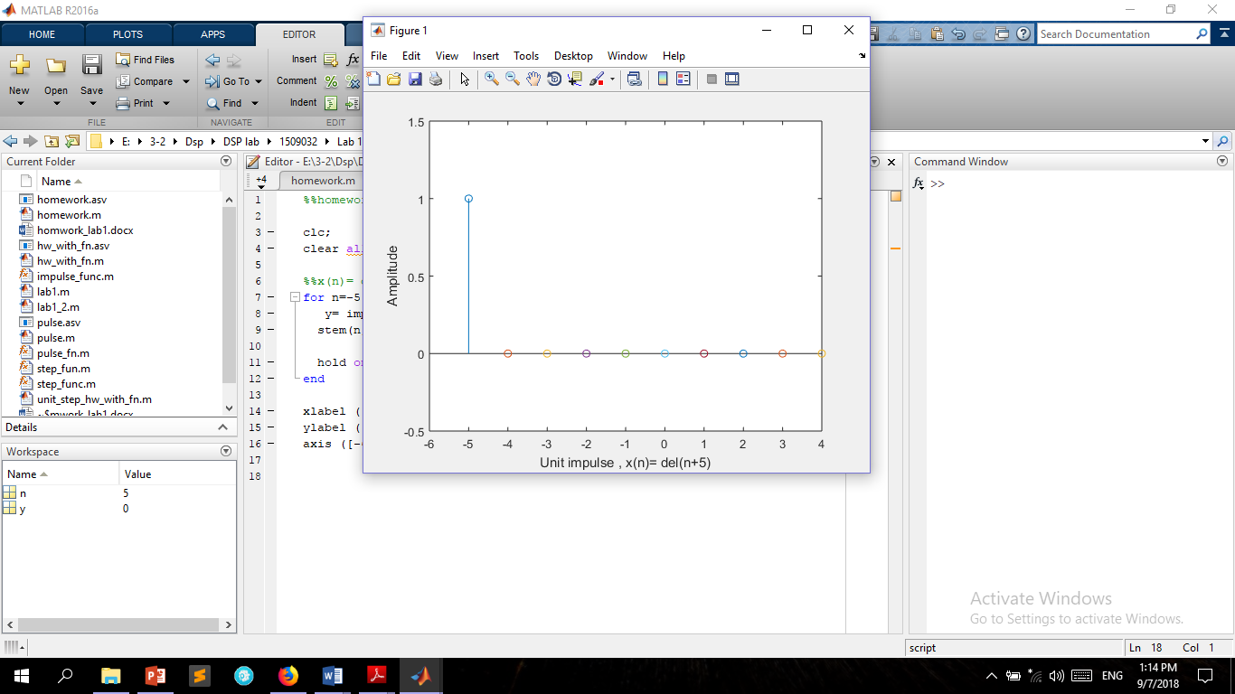

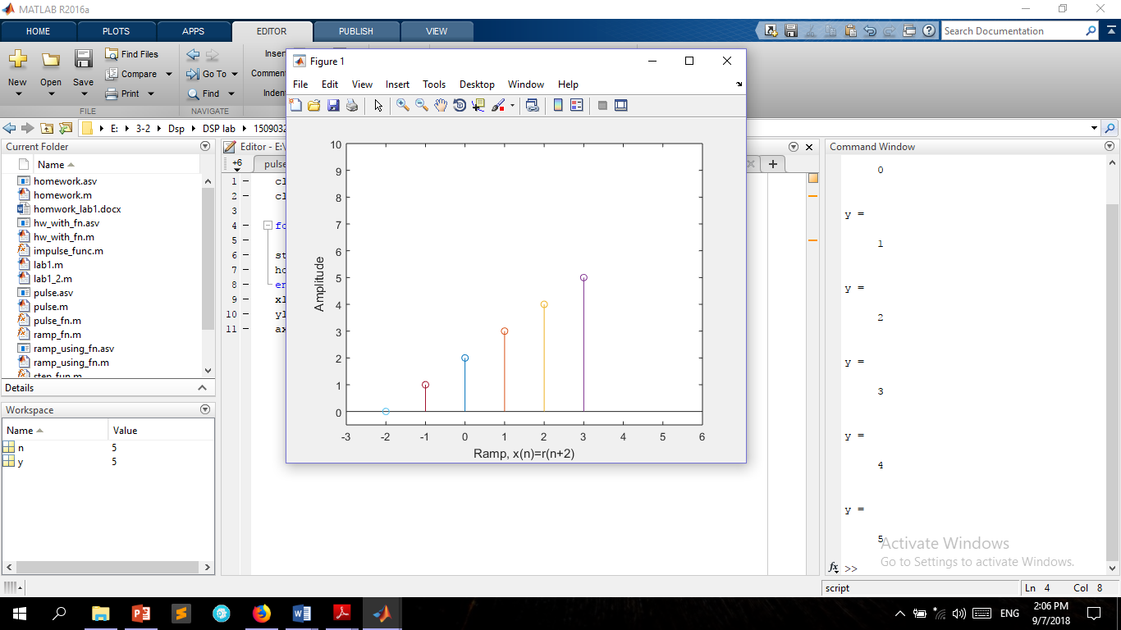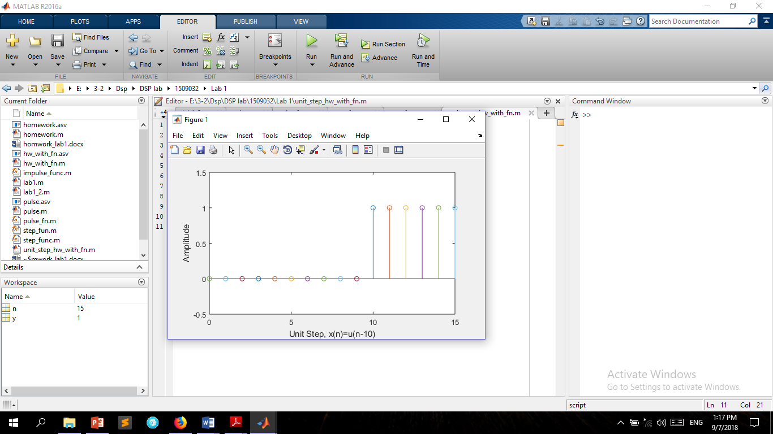

Figure 1.11: Ramp, x(n)=r(n+2)

Figure 1.10: Unit Step, x(n)=u(n-10)

Figure 1.9: Unit impulse signal, x(n)= ∂(n+5)

Home Works:

Defining the signals manually :

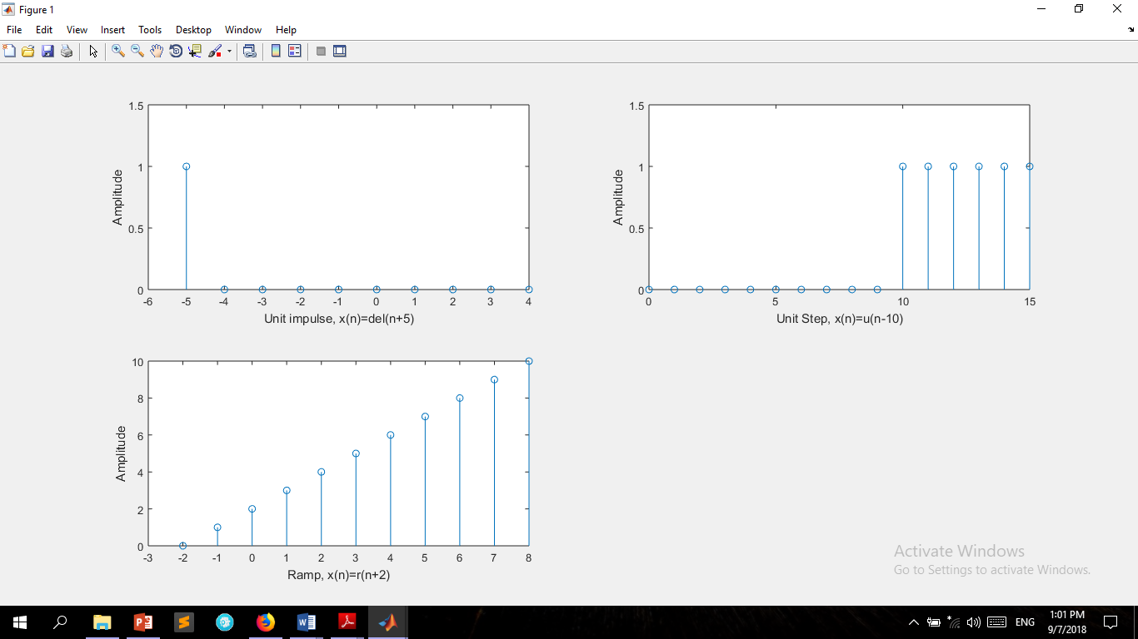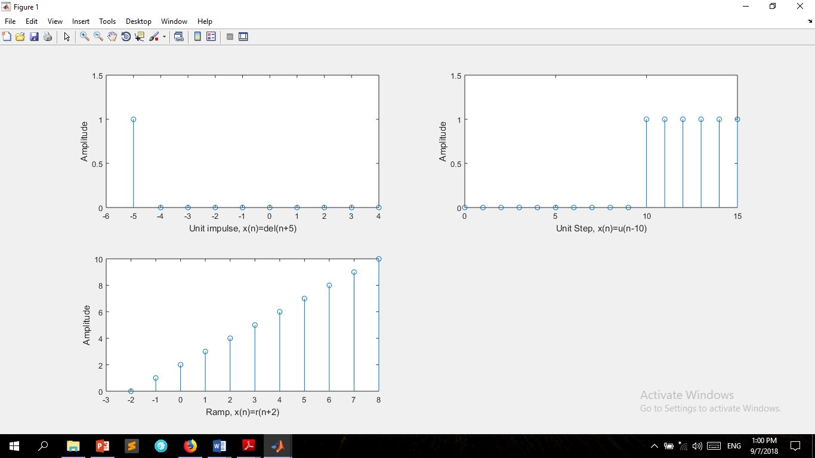

Figure 1.8: Ramp, x(n)=r(n+2)

Figure 1.7: Unit Step, x(n)=u(n-10)

Figure 1.6: Unit impulse signal, x(n)= ∂(n+5)

Class Works:

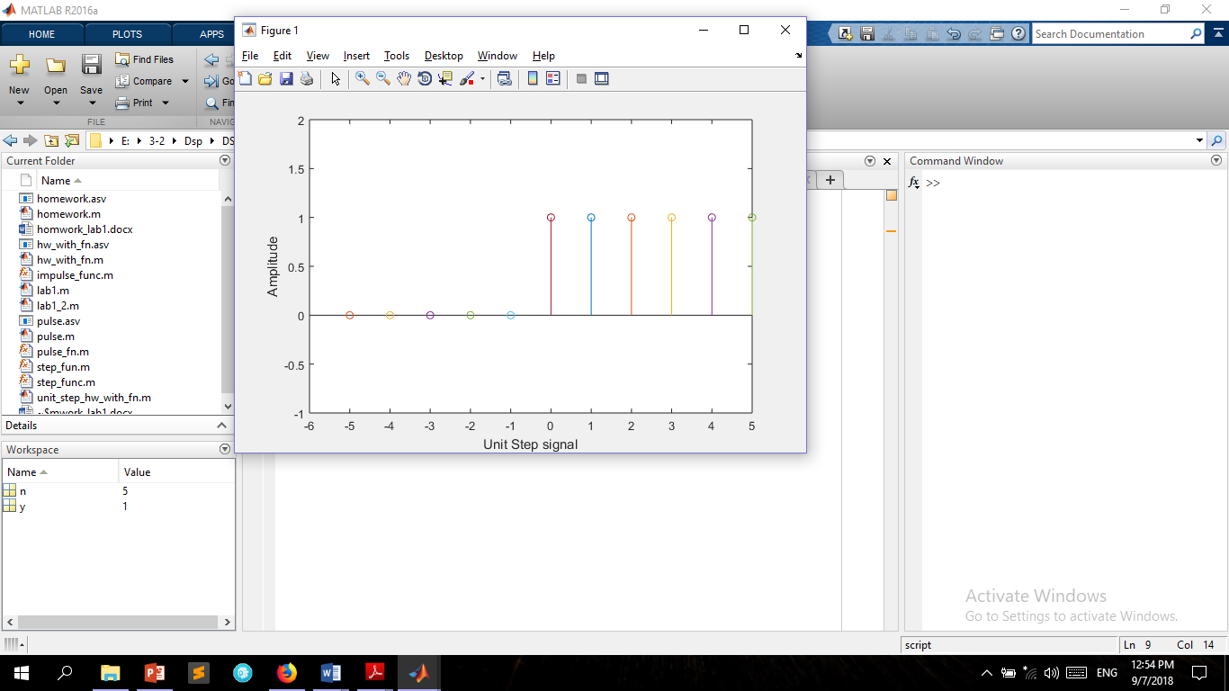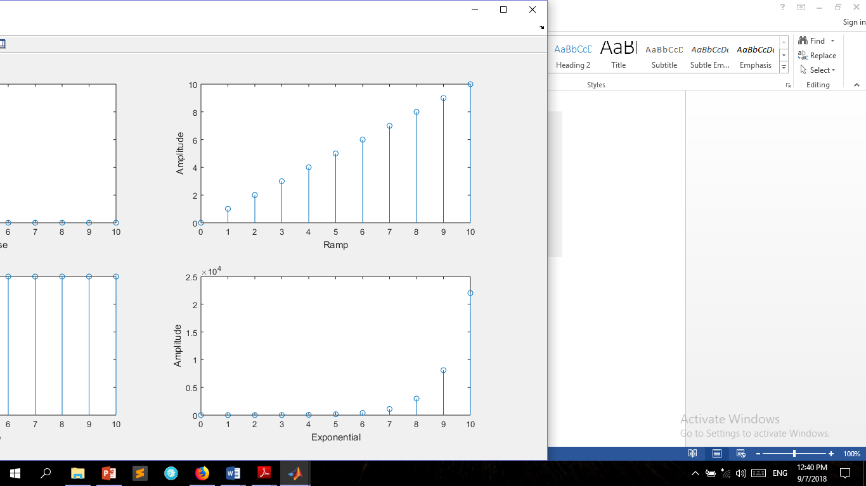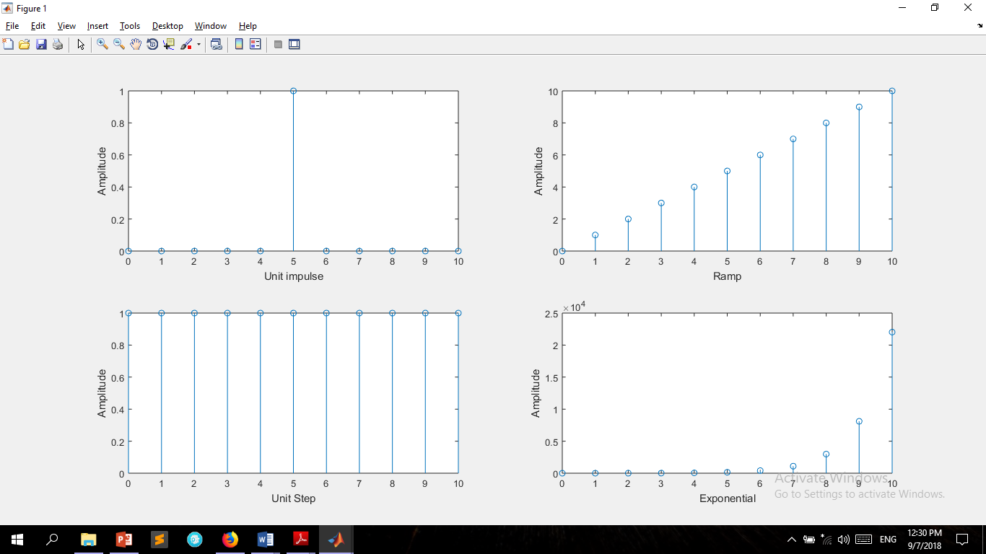

Figure 1.5: Unit Step signal (using function)

Figure 1.4: Exponential signal

Figure 1.3: Unit Step signal

Class Works:





Figure 1.2: Ramp signal

Figure 1.1: Unit Impulse signal